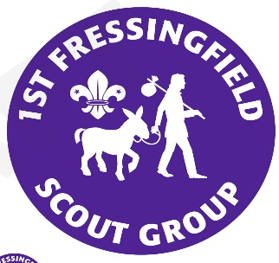


1st Fressingfield Scout Group.
Activity Information and Parental Permission Form – Shooting
Written parental permission is needed before a young person can take part in this activity

Activity Information:
Air rifle and pistol shooting
Date or period: Annual permission for the period January – December 2021.
Location: Varying locations in the UK.

Administrative Information:
Leader Team:
Andrew Aalders-Dunthorne, Contact details: 07908 262623 or andrew.aaldersdunthorne@talk21.com
Colin Clarke, Contact details: 07946 044065 or clarkecolin55@googlemail.com
Michael Knights, Contact details: 07761 827053 or michaelknightshoxne@gmail.com

If any additional information is required please do not hesitate to contact the Leader of the activity.

Parent or Guardian's consent
I, being the parent/guardian of the person named below, declare that he/she is not subject to restriction by virtue of Section 21 of the Firearms Act 1968 (which applies only to persons who have served a term of imprisonment or youth custody) and give permission for:
_______________________________________________________________________(name of young person)
to take part in air rifle and air pistol shooting.

Please state if he/she has a disability or medical condition relevant to this activity:
___________________________________________________________________________________________
Please indicate details of any medical treatment they are receiving at the moment:
___________________________________________________________________________________________

Contact details in the event of an emergency: ____________________________________Tel:______________

Name_______________________Signature__________________________________Date_________________

Extracts from the Firearms Act 1968

“Section 21”
(1) A person who has been sentenced (to custody for life or) to preventive detention, or to imprisonment or to corrective training for a term of three years or more (or to youth custody (or detention in a young offender institution) for such a term), or who has been sentenced to be detained for such a term in a young offenders institution in Scotland, shall not at any time have a firearm or ammunition in his possession.
(2) A person who has been sentenced ….. to imprisonment for a term of three months or more but less than three years (or to youth custody (or detention in a young offender institution) for such a term), or who has been sentenced to be detained for such a term in a detention centre or in a young offenders institution In Scotland, shall not at any time before the expiration of the period of five years from the date of his release have a firearm or ammunition in his possession.

This means:
Section 21 prohibits the possession of a firearm and ammunition (under any circumstances), by any person who has been convicted of a crime and sentenced to a term of imprisonment (or its equivalent for young persons) of 3 months or more. The prohibition applies in all circumstances, including handling and firing at an approved shooting club or at a clay pigeon shoot where a certificate is not ordinarily required. It also applies to the possession or use of other categories of firearms and ammunition such as AIRGUNS or shot cartridges for which a certificate is not needed. A sentence of 3 months to 3 years attracts a 5 year prohibition, shorter ones no prohibition but a longer one means a life ban.

