

1st Fressingfield Scout Group.
Kenyan Explorer Scout link.

1st Fressingfield Scout Group has its newest and most remote member (yes! Even more remote than Brundish!). Stephen has been enrolled as a member of the Explorer Unit here in Fressingfield – he has been sent his necker, membership badges and Investiture certificate.

Our pledge to Stephen is that we back here in the UK will support him through high school, by paying his school fees. We have the aim to change someone’s life for ever by extending a hand of friendship and to raise £270 per year – to ensure Stephen can work towards his own personal dream.

Your help this year and the coming years will be welcomed. Thank you.

Andrew Aalders-Dunthorne (Group Scout Leader, 1st Fressingfield)

STEPHEN NAINGANDA MUNKI
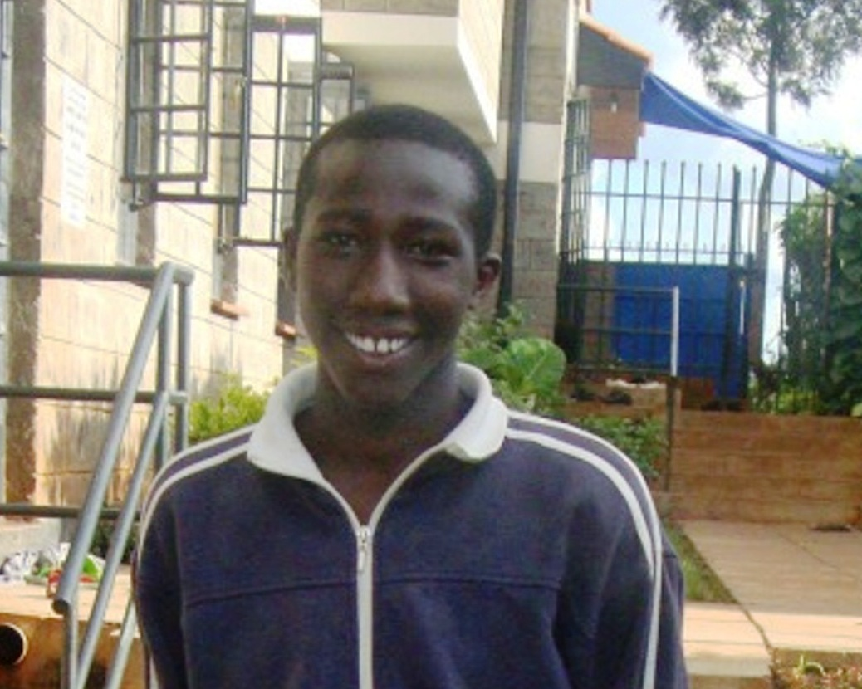
He is a sixteen year old last born in a family of four children cared for by his Aunt. His mother is alive but mentally ill. He is good in class, active in outdoor games and very kind, humble, responsible and neat with a desire to become an Engineer. He is from the Ng’ong Archdeaconry.

