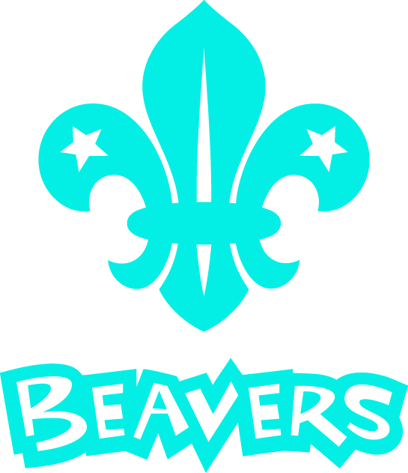

Fressingfield Scout Group Old Boys, and Girls, Network
Fressingfield Scouts are trying to contact anyone who was involved with Scouting in Fressingfield in the past. The Old Boys, and Girls, Network is an informal group with the simple aim of meeting up, reviving memories and catching up with old friends and colleagues.

We plan to have 2 or 3 get togethers a year as well as supporting Scout Group social activities.

Whether you were involved as a Beaver, Cub, Scout, Venture Scout, Explorer, Leader, Helper or on the Group Executive (Parents) committee in the past please get in touch to join this informal network.

Here is an archive picture, we think from the early seventies, can you see yourself or can you name some of these young people.

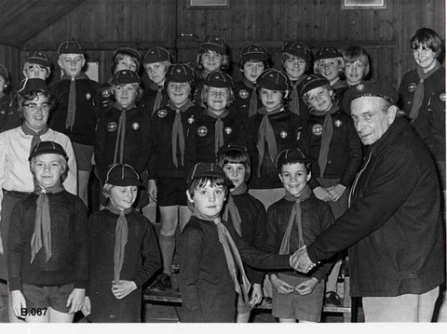

If you were a member of the group but do not wish to join the network, we would be very interested in any memorabilia such as badges, uniforms, books, and especially photographs you may have either as a gift to our archive or to copy. Please contact us if you have anything.

Contact
Michael Knights
email daganyafarm@tiscali.co.uk
01379 668060
Or
Eammon Andrews
email eammonandrews@gmail.com
01379 384207

